**Batch:** B1 **Roll Number:** 1914078 **Name:** Devansh Shah

**Experiment Number:** 5

**Aim of the Experiment**: Write a program for implementation of family tree in PROLOG using condition- action rules-based agent.

**Program/ Steps:**

**Family Tree Prolog Code:**

# female(kinjal).

# female(prerna).

# female(kavita).

# female(deena).

# female(leena).

# male(tejas).

# male(dharmil).

# male(deepil).

# male(maulik).

# male(rakesh).

# parent(prerna,maulik).

# parent(tejas,kinjal).

# parent(prerna,deepil).

# parent(tejas,deepil).

# parent(kavita,deena).

# parent(dharmil,deena).

# parent(kavita,maulik).

# parent(dharmil,maulik).

# parent(leena,tejas).

# parent(rakesh,tejas).

# parent(leena,dharmil).

# parent(rakesh,dharmil).

# mother(X,Y):-parent(X,Y),female(X).

# father(X,Y):-parent(X,Y),male(X).

# child(X,Y):-parent(Y,X),X\==Y.

# sibling(X,Y):-parent(Z,X),parent(Z,Y),X\==Y.

# sister(X,Y):-sibling(X,Y),female(X).

# brother(X,Y):-sibling(X,Y),male(X).

# grandparent(X,Y):-parent(X,Z),parent(Z,Y).

# grandmother(X,Z):-mother(X,Y),parent(Y,Z).

# grandfather(X,Z):-father(X,Y),parent(Y,Z).

# spouse(X,Y):-parent(X,Z),parent(Y,Z),X\==Y.

# uncle(X,Y):-brother(X,Z),parent(Z,Y).

# aunt(X,Y):-sister(X,Z),parent(Z,Y).

# wife(X,Y):-spouse(X,Y),female(X),male(Y).

# husband(X,Y):-spouse(X,Y),male(X),female(Y).

# cousin(X,Y):-child(X,W),sibling(W,Z),parent(Z,Y).

# Output:

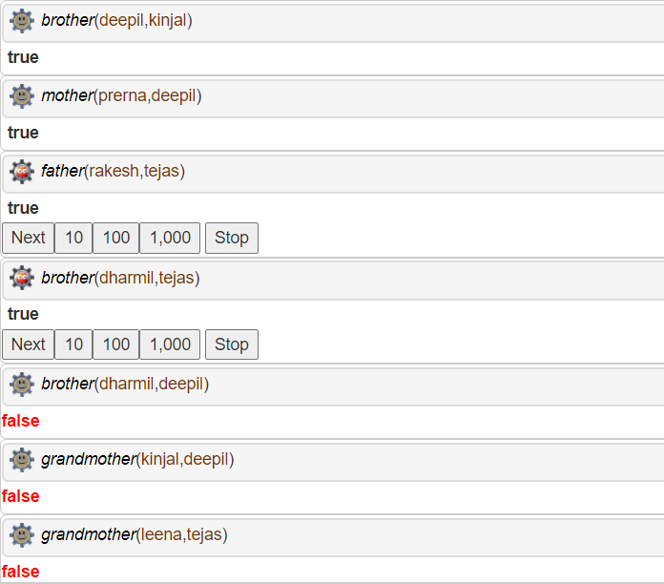

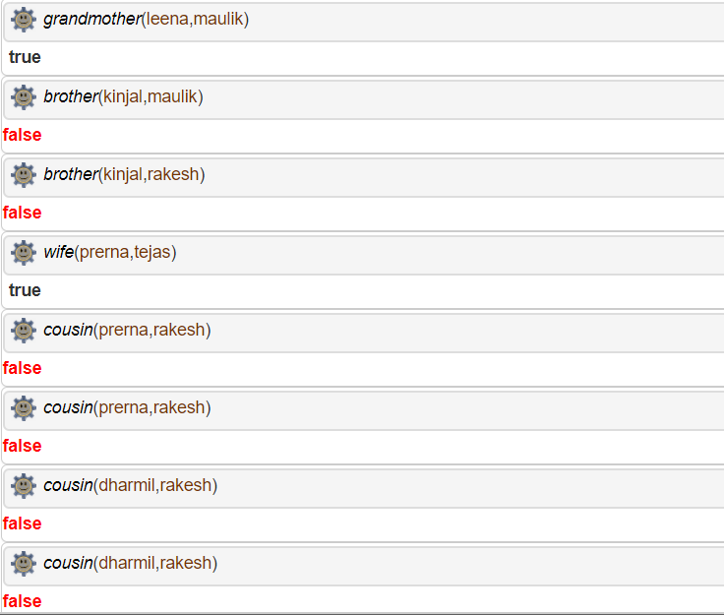

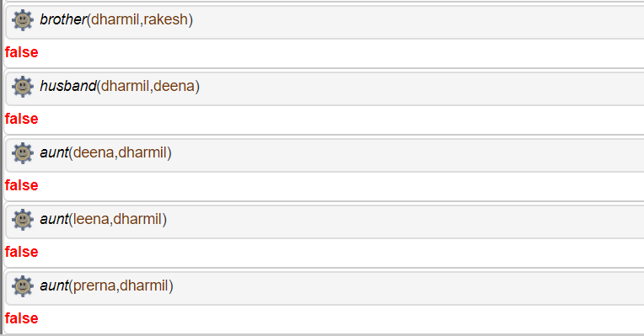

**Post-Lab Questions:**

**1. The PROLOG suit is based on**

a. Interpreter

b. Compiler

c. None of the above

d. Both

**Answer:** d) Both

**2. State true of false**

There must be at least one fact pertaining to each predicate written in the PROLOG program.

**Answer:** d) **True**

**3. State true of false**

In PROLOG program the variable declaration is a compulsory part.

**Answer:** d) **False**

**4. Differentiate between a fact and a predicate with syntax.**

**Answer:** A predicate is defined by a set of clauses with the same principal functor and arity. Facts are indeed special cases of rules: rules that are always true and relation (X, Y) is equivalent to relation(X, Y) :- true, where true/0 is a built-in predicate that always succeeds.

**5. Differentiate between knowledge base and Rule base approach.**

**Answer:** Rule-based systems process data and output information, but they also process rules and make decisions. They are good at processing lots of simple business rules with broad logic. Knowledge-based systems also process data and rules to output information and make decisions. In addition, they also process expert knowledge to output answers, recommendations, and expert advice. They are good at processing deep logic and very complex business rules. They are commonly used for advising systems, expert systems, and knowledge automation.

**Outcomes:**

**CO3:** Ability to formally state the problem and develop the appropriate proof for given a logical deduction problem

**Conclusion:** We implemented a program for implementation of family tree in PROLOG using condition- action rules-based agent and used the SWISH software for performing the PROLOG program execution.

**References:**

* Stuart Russell and Peter Norvig, Artificial Intelligence: A Modern Approach,

Second Edition, Pearson Publication

* Elaine Rich, Kevin Knight, Artificial Intelligence, Tata McGraw Hill, 1999.